|  |  |  |  |  |  |  |
| --- | --- | --- | --- | --- | --- | --- |
|  |  |  | 1 |  |  |  |
|  |  | 1 |  | 1 |  |  |
|  | 1 |  | 2 |  | 1 |  |
| 1 |  | 3 |  | 3 |  | 1 |

**Dry Run (logic) for Pascal Triangle**

4 rows 7 column

6 rows 11 column

|  |  |  |  |  |  |  |  |  |  |  |
| --- | --- | --- | --- | --- | --- | --- | --- | --- | --- | --- |
|  |  |  |  |  | 1 |  |  |  |  |  |
|  |  |  |  | 1 |  | 1 |  |  |  |  |
|  |  |  | 1 |  | 2 |  | 1 |  |  |  |
|  |  | 1 |  | 3 |  | 3 |  | 1 |  |  |
|  | 1 |  | 4 |  | 6 |  | 4 |  | 1 |  |
| 1 |  | 5 |  | 10 |  | 10 |  | 5 |  | 1 |

|  |  |  |  |  |  |  |  |  |  |  |  |
| --- | --- | --- | --- | --- | --- | --- | --- | --- | --- | --- | --- |
|  | 1 | 2 | 3 | 4 | 5 | 6 | 7 | 8 | 9 | 10 | 11 |
| 0 |  |  |  |  |  | 1 |  |  |  |  |  |
| 1 |  |  |  |  | 1 |  | 1 |  |  |  |  |
| 2 |  |  |  | 1 |  | 2 |  | 1 |  |  |  |
| 3 |  |  | 1 |  | 3 |  | 3 |  | 1 |  |  |
| 4 |  | 1 |  | 4 |  | 6 |  | 4 |  | 1 |  |
| 5 | 1 |  | 5 |  | 10 |  | 10 |  | 5 |  | 1 |

Row start with 0 and column start with 1 , here we have 6 row (0 to 5) an 11 columns (1 to 11).

Leave blank space between each value.

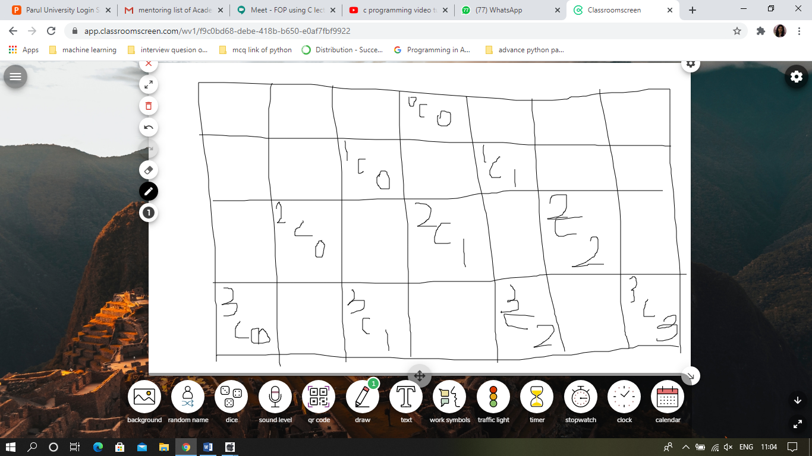

**nCr = n!/(r! * (n-r)!)**

**2c1 = 2!/1!*(2-1)! = 2/1*1 = 2/1 = 2**

**3c1 = 3!/1!*(3-1)! = 6/1*2 = 6/2 = 3**

**5C2 = 5!/2!*(5-2)! = 120/2*6 = 120/12 = 10**

**5C4 =**

**In below code nr=total numbers of rows. Entered by user.**

for(i=0; i<nr; i++)

{

for(k=0; k<nr – I; k++)

{

Printf(“ “);

}

N=1;

For(j=0; j<=I; j++)

{

Printf(“%d ”,N);

N = N*(i-j)/(j+1)

}

Printf(“\n”);

}